**WITH CLAUSE**

With clause also called as common table expression. Used to create a temporary table which is not stored on disk or server, if the particular query execution process is completed then it will be finished.

In below example we took average salary by with and that average salary are then used in another query.

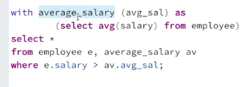

**Difference between with clause and view**

| **Feature** | **WITH Clause (CTE)** | **VIEW** |
| --- | --- | --- |
| Duration | Temporary (per query) | Persistent (stored) |
| Reusability | Only within that query | Across many queries |
| Scope | Single query | Database-wide |
| Modifiability | Defined in the query | Defined and stored |
| Performance | Generally not indexed | Can be indexed (materialized) |
| Use Case | Complex queries, recursion | Abstraction, reuse, security |